**CASE STUDY 1**

**Xen Architecture:**

Xen is an open-source virtualization platform that provides a powerful and flexible framework for running a single physical server housing several virtual machines (VMs). Here's an elaborate explanation of the Xen architecture:

1. Hardware Layer:

- At the foundation of the Xen architecture is the physical server hardware. This includes the memory, storage devices, CPU, and network interfaces.

2. Xen Hypervisor:

- The core component of the Xen architecture is the Xen hypervisor. It is a lightweight, bare-metal hypervisor that runs directly on the physical hardware. The Xen hypervisor is responsible for managing and controlling the virtualization process.

- The Xen hypervisor is a privileged component with direct access to the hardware, allowing it to allocate and manage resources efficiently.

- It does not contain an entire operating system but provides a thin layer of control between the hardware and the guest VMs.

- The Xen hypervisor is often called "Domain 0" or "Dom0." Dom0 is a VM granted privileged access to the hypervisor and acts as a control domain. It typically runs a minimalistic operating system, often a stripped-down Linux distribution. Dom0 manages the Xen environment, creating, configuring, and monitoring other VMs.

3. Virtual Machines (DomU):

- Xen can run multiple virtual machines on top of the hypervisor, referred to as "Domain U" or "DomU." DomU VMs run complete guest operating systems and applications.

- Each DomU operates as an isolated, independent virtual environment, unaware of the presence of other VMs. This separation ensures that one VM's security and performance don't affect others.

- Xen uses a paravirtualization technique, which requires slight modifications to the guest operating systems to enhance performance and resource sharing between the hypervisor and VMs. Alternatively, Xen can also support hardware virtualization (HVM) for unmodified guest OSes.

- The resource allocation, scheduling, and management of DomU VMs are controlled by the Xen hypervisor, providing fine-grained control over CPU, memory, and other resources.

**Key Features and Benefits:**

1. Resource Isolation: Xen's architecture provides strong isolation between VMs. VMs are sandboxed, preventing one VM from interfering with the operation of others ensuring security and stability.

2. Efficient Resource Utilization: The hypervisor efficiently allocates physical resources to VMs, maximizing server utilization and reducing hardware costs.

3. Live Migration: Xen supports live migration, allowing VMs to be moved between physical hosts with minimal downtime, ensuring high availability.

4. Hardware Compatibility: Xen is known for its broad hardware support and compatibility with various CPU architectures.

5. Performance: Xen offers good performance by minimizing virtualization overhead through techniques like paravirtualization and hardware virtualization support.

6. Support for Multiple Guest OSes: Xen can run various guest operating systems, including Linux, Windows, and others, making it versatile for different use cases.

In summary, the Xen architecture provides a robust, efficient, and secure virtualization environment for running multiple VMs on a single physical server. Its lightweight hypervisor and strong isolation between VMs make it an attractive choice for organizations looking to optimize server resource utilization and provide secure virtual environments for their workloads.

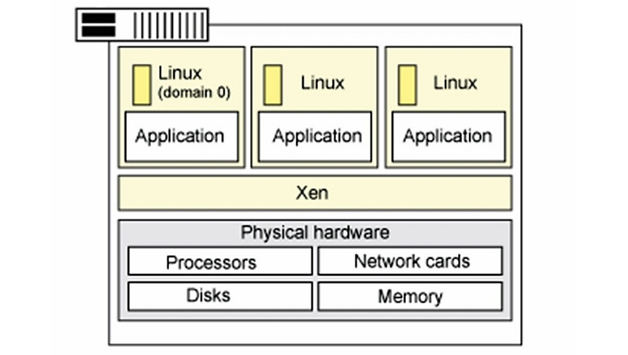

**Case Study: Optimizing Server Infrastructure with Xen Virtualization**

**Company Background:**

ABC Corporation is a medium-sized enterprise specializing in web hosting services. As their customer base grows, they face the challenge of efficiently managing their server infrastructure. They opt for Xen virtualization to improve resource utilization and enhance server management.

**Challenges:**

ABC Corporation had several challenges to address:

1. Resource Utilization: They needed to use their server resources better, as many servers were underutilized.

2. Server Management: Managing multiple physical servers and operating systems was becoming complex and time-consuming.

3. Isolation: Ensuring strong isolation between customer workloads to prevent resource conflicts and security issues.

Solution:

ABC Corporation chose Xen as their virtualization solution to overcome these challenges. Xen's architecture and features provided the company with a robust virtualization platform.

**Xen Architecture:**

Hardware Layer:

- The physical server hardware forms the foundation of the Xen architecture.

Xen Hypervisor:

- Xen includes a hypervisor, a lightweight, low-level software layer that directly interfaces with the hardware.

- The Xen hypervisor runs on the physical server and manages the allocation of resources to virtual machines (VMs).

- It serves as the "Dom0" (domain 0) and runs a privileged guest operating system responsible for managing the other VMs.

- Dom0 often uses a trimmed-down Linux distribution, which provides essential device drivers and management tools.

Virtual Machines (DomU):

- The Xen hypervisor can host multiple guest VMs, referred to as "DomU" (unprivileged domains).

- Each DomU runs its complete operating system, such as Linux, Windows, or another OS.

- DomU VMs share the physical server's resources but are isolated, ensuring one VM cannot interfere with another.

**Key Benefits:**

1. Resource Utilization: Xen allows ABC Corporation to operate several virtual machines on a single physical server efficiently. This optimizes resource utilization and reduces server sprawl.

2. Isolation: The strong isolation between DomU VMs ensures that customer workloads remain separate, preventing resource contention and security breaches.

3. Manageability: The architecture simplifies server management. ABC Corporation can use the Dom0 guest OS to monitor and control the VMs.

4. Compatibility: Xen is compatible with various guest operating systems, giving ABC Corporation flexibility in supporting multiple customer requirements.

**Results:**

Implementing Xen virtualization helped ABC Corporation achieve the following outcomes:

- Improved resource utilization, reducing the need to purchase additional physical servers.

- Enhanced customer workload isolation, resulting in a more secure hosting environment.

- Simplified server management, saving time and reducing administrative overhead.

- Greater flexibility in meeting diverse customer demands by supporting multiple guest operating systems.

In conclusion, by adopting Xen virtualization, ABC Corporation successfully addressed its resource utilization, management, and isolation challenges. The architecture's flexibility and strong isolation capabilities have allowed them to provide a more efficient and secure hosting service to their customers while streamlining their server management processes.

**CASE STUDY 2**

**KVM Architecture:**

Indeed, let's elaborate on the Kernel-based Virtual Machine (KVM) architecture, a popular open-source virtualization solution for Linux-based systems. KVM leverages the Linux kernel to provide virtualization capabilities. Here's a detailed breakdown of the KVM architecture:

1. Hardware Layer:

- At the foundation of the KVM architecture is the physical server hardware, which includes the CPU, memory, storage, and network interfaces.

2. Linux Kernel:

- KVM is a kernel module that is part of the Linux kernel. This module extends the Linux kernel's functionality to support virtualization. It converts the host Linux kernel into a hypervisor.

3. KVM Module:

- The KVM module is responsible for managing and controlling virtual machines. It interacts with the host's hardware through the standard Linux kernel interfaces and system calls.

4. User Space Tools:

- KVM provides user-space tools that allow administrators and It is possible to create, configure, and manage virtual machines. By users. These tools include QEMU, libvirt, and other management interfaces.

5. Guest Virtual Machines (VMs):

- Virtual machines running on KVM are known as guest VMs. Each guest VM has its operating system, file system, and applications.

- The KVM module ensures that the VMs can run in a secure and isolated manner, utilizing the host's physical resources.

6. Guest Operating Systems:

- Each guest VM runs its operating system, such as Linux, Windows, or another supported OS.

- These guest OSes can be customized and configured independently of each other.

**Essential Components and Processes:**

- KVM Hypervisor: The KVM module, part of the Linux kernel, acts as a lightweight hypervisor, allowing the creation and management of VMs. It provides a set of APIs and services for handling VM operations.

- Hardware Virtualization Extensions: KVM leverages hardware virtualization extensions provided by modern CPUs, such as Intel VT-x or AMD-V. These extensions enhance virtualization performance and security.

- Memory Management: KVM manages memory allocation and translation, ensuring that guest VMs have their virtual memory space mapped to the host's physical memory.

- CPU and Scheduler Management: KVM provides CPU scheduling and resource management for guest VMs, allowing them to share the host's CPU resources efficiently.

- I/O and Device Virtualization: KVM interfaces with the host's I/O subsystem to access virtualized devices. It emulates hardware devices or can use paravirtualized drivers for optimal I/O performance.

- User Space Tools: User-friendly tools and management interfaces, like QEMU and libvirt, facilitate VM creation, configuration, and monitoring.

**Benefits of KVM Architecture:**

1. Performance: KVM leverages hardware virtualization extensions, providing near-native performance for guest VMs.

2. Linux Integration: KVM seamlessly integrates with the Linux kernel and takes advantage of Linux's features, making it an excellent choice for Linux-based environments.

3. Support for Diverse Guest OSes: KVM supports various guest operating systems, including Linux, Windows, and other popular OSes.

4. Open Source: KVM is open-source software that is cost-effective and allows for community-driven development and support.

In conclusion, the KVM architecture leverages the Linux kernel to provide efficient and secure virtualization. It offers near-native performance, broad guest OS support, and the benefits of open-source software, making it a well-liked option for businesses wishing to adopt virtualization solutions on Linux-based servers.

Certainly! Here's a case study on KVM (Kernel-based Virtual Machine) architecture for a hypothetical company, "TechCo," that has adopted KVM for their virtualization needs.

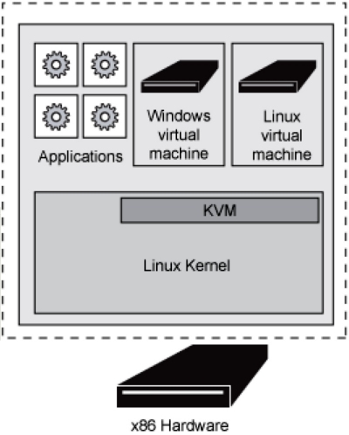

**Case Study: Implementing KVM Virtualization at TechCo**

**Background:**

TechCo is a medium-sized technology company looking to streamline its IT infrastructure and improve resource utilization while ensuring strong isolation between services. They decided to implement KVM virtualization technology to achieve these objectives.

**Business Objectives:**

1. Resource Utilization: TechCo wants to efficiently use its server hardware by running multiple virtual machines on each physical server.

2. Isolation: The company needs strong isolation between services and departments to maintain security and prevent disruptions.

3. Scalability: TechCo aims to scale its virtualization environment as its business proliferates.

**KVM Architecture Implementation:**

TechCo adopts the following KVM architecture:

**Components:**

- Hardware Host: TechCo's physical server hardware has a Linux operating system and KVM support.

- KVM Hypervisor: KVM is integrated into the Linux kernel, allowing multiple virtual machines to run on the same host. It leverages the host OS's kernel for hardware management.

- Guest VMs: TechCo runs multiple virtual machines on each physical server to host various services. For example, VM1 is dedicated to the database, VM2 to web hosting, VM3 to application services, and so on.

Implementation Details:

1. Resource Utilization: By implementing KVM, TechCo can efficiently utilize its server hardware. Each VM can be allocated a specific amount of CPU, memory, and storage resources, ensuring they maximize their physical servers.

2. Isolation: KVM provides strong isolation between VMs. Each VM runs its own OS, which enhances security and minimizes the risk of one service affecting another.

3. Scalability: TechCo can quickly scale its virtualization environment. When they need to expand their infrastructure, they can add more physical servers and create additional VMs without significant disruptions.

**Benefits:**

- Improved Hardware Utilization: KVM enables TechCo to consolidate multiple services onto a single server, reducing the number of needed physical servers.

- Enhanced Security: Strong isolation between VMs ensures that if one VM is compromised, it doesn't impact other services running on the same host.

- Scalability: As TechCo's business grows, it can scale its virtualization environment by adding more hardware hosts and VMs.

**Challenges:**

- Requires Linux Proficiency: KVM is tightly integrated with the Linux kernel, so TechCo needs Linux expertise to manage its virtualization environment effectively.

- Management Complexity: Managing multiple VMs and ensuring resource allocation can be complex, necessitating using tools like virt-manager or oVirt.

In conclusion, TechCo successfully implemented KVM virtualization to improve resource utilization, enhance security through isolation, and ensure scalability for their growing technology infrastructure. This case study illustrates how KVM can benefit companies looking to optimize their IT resources while maintaining strong service separation and security.